ABOUT COMO NEIGHBORHOOD

You are entering the Como neighborhood of Southeast Minneapolis, a small residential neighborhood surrounded by industrial areas but which remains an urban oasis sprinkled with carefully-tended community gardens. To the south, between Como and the historic East Bank campus of the University of Minnesota, lies the South East Minneapolis Industrial (SEMI) Area.
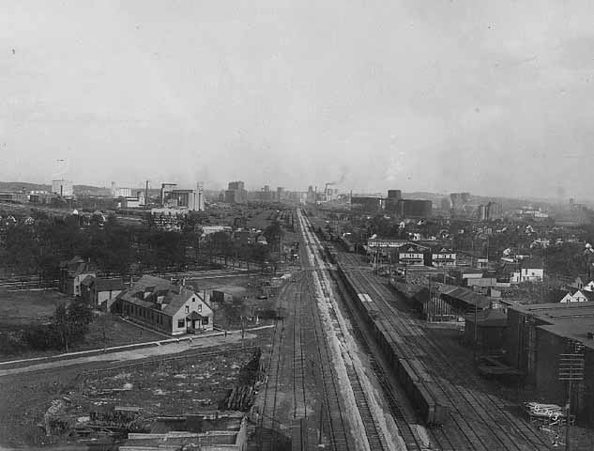
Southeast Minneapolis, Great Northern tracks running toward St. Paul, treed area at left is Van Cleve Park: Charles P. Gibson, ca. 1920, Minnesota Historical Society

Elm Street and the former Great Northern Railway (now BNSF) form the southern border of Como. This rail line was built in 1867 from St. Paul to St. Cloud and was the second railroad line constructed in Minnesota. By the early 20th century, numerous grain elevators and feed mills sat along both sides of the Great Northern line and the freight rail yard built here.

The Bunge elevator (1936-2007) was a Como neighborhood icon that occupied the historic site of the Midway elevator (1880s) on 12th Avenue SE. The Bunge tower, to your west, is now part of an innovative housing development.
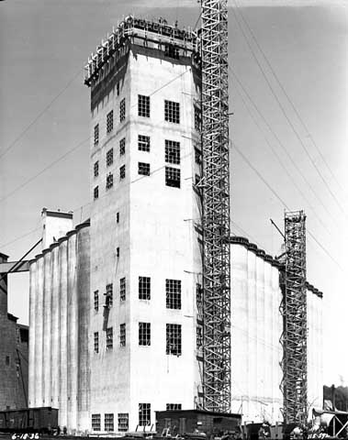

Como’s residential area was originally developed in the 1880s on marshland with deep peat deposits. Later housing spurts occurred in the 1920s and 1950s. Many distinctive American styles of houses can be seen throughout Como, from 1800s Greek Revival and Victorian, turn-of-century Bungalow and Arts and Crafts, to post-World War II Ranch styles.
Bunge Elevator construction: Norton & Peel, 1936, Minnesota Historical Society
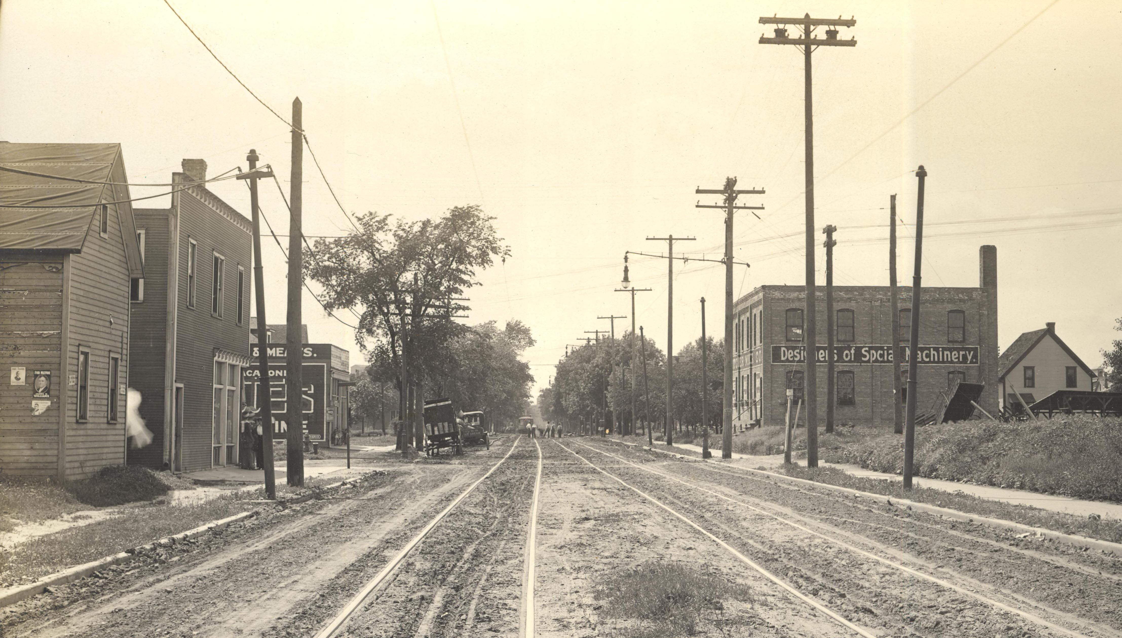

Como represents a classic “streetcar neighborhood”, built along the important Como-Harriet line, the longest streetcar line in the Twin Cities and a major link between Minneapolis and St. Paul from the 1910s to 1954. Clusters of small businesses grew at streetcar stops throughout the neighborhood.
Como Avenue streetcar line near 22nd Avenue SE, looking west: C.J. Hibbard, 1914, Minnesota Transportation Museum

Van Cleve Park, at 15th and Rollins Avenues, was established in 1890 as the Second Ward Park. It was renamed in 1895 to honor Civil War General Horatio Van Cleve and his wife Charlotte Ouisconsin Van Cleve, a civic leader and chronicler of pioneer life at Fort Snelling and in Minnesota. The park was expanded and a new community center built in 1969. The South East Como Improvement Association devoted significant Neighborhood Revitalization Program funds for further renovations in 2001.
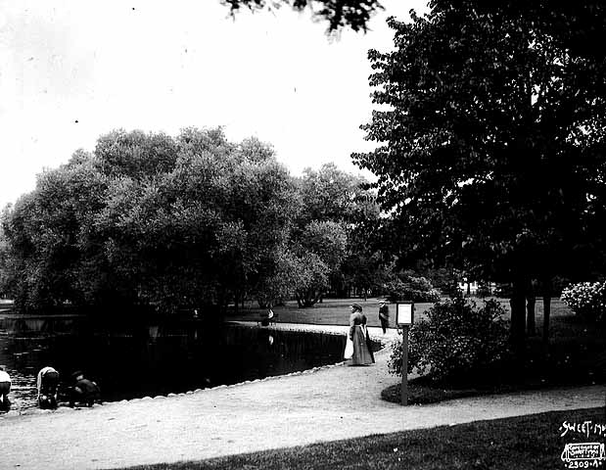
Van Cleve Park, Minneapolis: Sweet, 1905, Minnesota Historical Society

Other points of interest in Como:

- The University of Minnesota Child Care Center, at 17th and Rollins Avenues, built in 1989 on the site of a former stock feed mill.

- The 1909-1920 home of Maria Sanford, the University’s first female professor, at 1050 13th Avenue SE.

- Tuttle School (1910; program since 1883) at 18th and Talmadge Avenues SE.
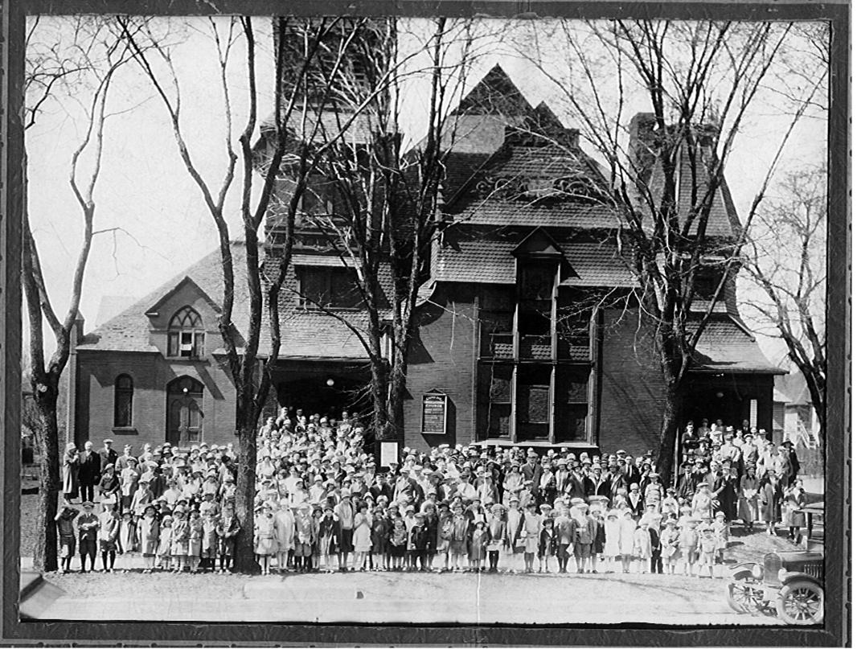

- The former Como Congregational Church (1886; Charles Sedgwick, architect) at 1037 14th Avenue, SE, now a museum of medieval and Renaissance arms and armor.

- The historic Donald Cattanach stone house at 1031 13th Avenue SE (1883).

- Bridal Veil Pond in east Como’s industrial area, visible off Kasota Avenue; this boggy area is the source of Bridal Veil Falls on the Mississippi River just north of Franklin Avenue SE.
Como Congregational Church: ca. 1910s,
Como Congregational Church

- The 19th Avenue SE home of Vice President Hubert H. Humphrey when he was Mayor of Minneapolis and first elected to the U. S. Senate in 1948.

