ABOUT COMO NEIGHBORHOOD

As you enter the Como neighborhood by crossing East Hennepin Avenue, Stinson Boulevard turns into 18th Ave. SE. Como is a secluded Minneapolis neighborhood, like a village in the middle of the city.

The Como neighborhood gets its name from the main street that traverses it from Interstate 35W to the east city limit with St. Paul. Como Avenue is named after the old Como Road of pioneer days that went from the city of St. Anthony (on the Mississippi River at St. Anthony Falls) to Como Lake in St. Paul.

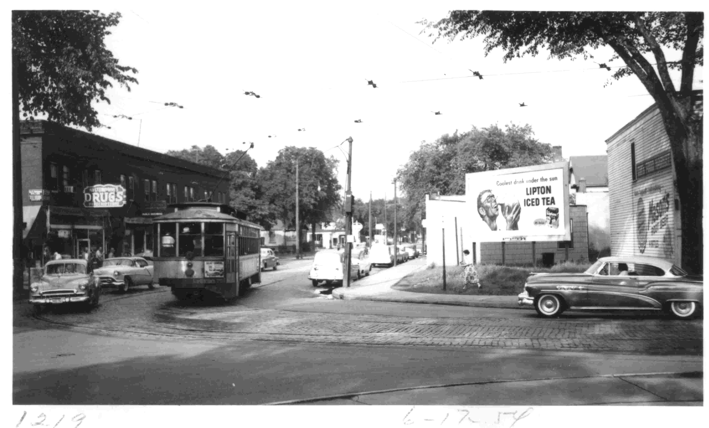
The Como neighborhood lies about one mile north of the original University of Minnesota campus. The residential area, and several retail nodes, grew along the streetcar line.

- Como Avenue had a busy streetcar line from the 1890s to 1954, with the Como-Harriet cars and the Intercampus cars that carried University of Minnesota students from the East Bank campus on the Mississippi River to the St. Paul campus. Thousands of Minneapolis residents rode the Como-Harriet line to reach the State Fair each summer.
Streetcar at 15th & Como Avenues SE: 1954, Minnesota Transportation Museum

- Talmadge Avenue commemorates Tallmadge Elwell, the first resident daguerrotypist at St. Anthony Falls (1851) and father of the Como neighborhood’s founder, James T. Elwell.

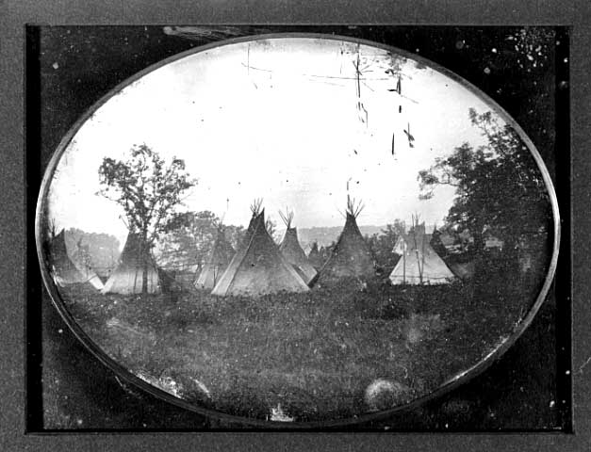
Indian tepees in Minneapolis: Tallmadge Elwell, ca. 1852, Minnesota Historical Society

St. Anthony Falls: Tallmadge Elwell,
ca. 1852, Minnesota Historical Society
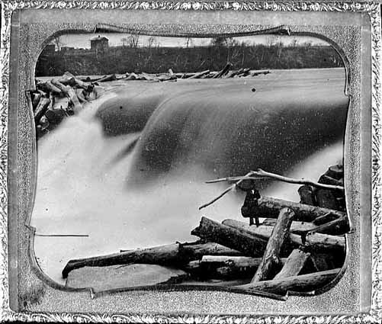

- Brook Avenue gets its name from a large creek that historically meandered southward from approximately the location of the avenue. That stream, called Tuttle’s Brook for pioneer lumberman Calvin A. Tuttle, flowed through land he owned and emptied into the Mississippi River near 14th Ave. SE.
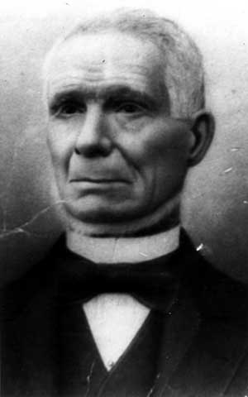

Calvin A. Tuttle:
ca. 1880, Minnesota Historical Society

- Rollins Avenue honors the pioneer lumberman and shipbuilder John Rollins, who first purchased the land that became the Como neighborhood.

- East Hennepin Avenue was originally called Division Street, because it divides the East Side of Minneapolis into Northeast and Southeast. In the 1920s and early 1930s, St. Paul-based gangsters escaped from the scenes of their Minneapolis crimes by driving over “Bank Robber’s Row”: East Hennepin Avenue to Larpenteur Avenue in St. Paul. They encountered few police roadblocks on this straight road, and St. Paul police protected them once they crossed the county line.

The railroad bridge next to you carries trains on the main line of the Burlington Northern Santa Fe Railroad. Built in 1885 by the Northern Pacific Railroad, the line cuts diagonally through Northeast and Southeast Minneapolis on its way to St. Paul.

The tracks’ higher grade meant that streets were blocked to traffic until underpasses were built, but Talmadge Avenue still has a visible grade differential at its crossing near 20th Avenue SE. More than 80 trains, including Amtrak, travel this line every day.

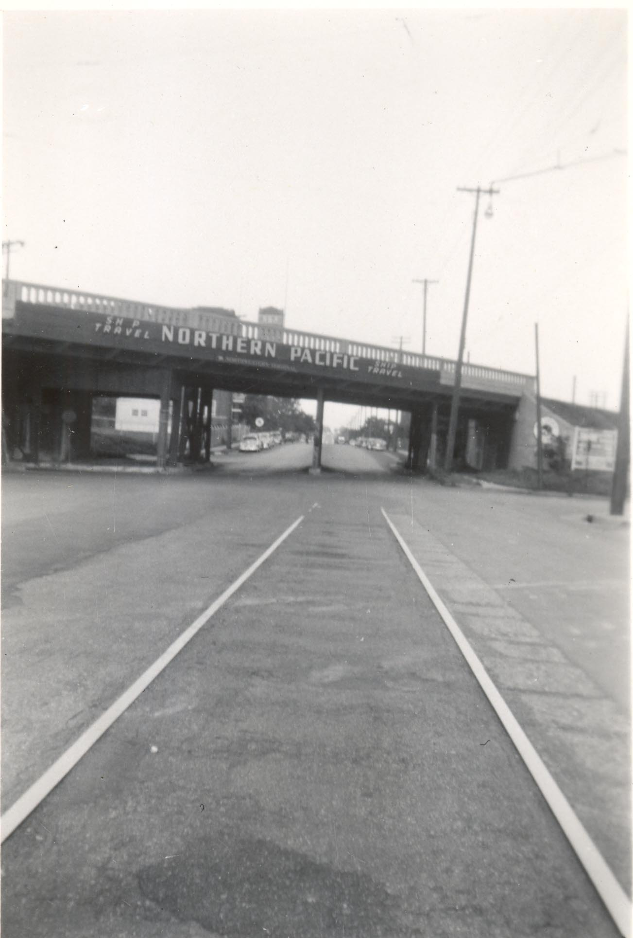
Railroad bridge over East Hennepin Avenue at Stinson Boulevard: ca. 1950s, Minnesota Transportation Museum

